**SRI LANKA INSTITUTE OF INFORMATION TECHNOLOGY**

USER EXPEIENCE ENGINEERING – SE3050

YEAR 3 SEMESTER 2 | 2020-REG-WE-44

**Group Members**

|  |  |
| --- | --- |
| **Registration No** | **Name** |
| **IT19115894** | **Jayasekara J.T.N.N.** |
| **IT19184272** | **R.H. Gunasekera** |
| **IT19046594** | **Sachintha Nipun M.M** |
| **IT19177410** | **Madhura Mihiranga H.N** |

**IT19115894 | Jayasekara J.T.N.N.**

**Task 01 – persona**



**Amal Gamage -** **Graphic Designer**

**Background**

* Amal is a graphic designer and is responsible for

create visual concepts by hand or by using computer software.

* He communicates ideas to inspire, inform, or captivate consumers through both physical and virtual art forms that include images, words, or graphics.
* He is doing freelance graphic designing works and have a very good reputation as a graphic designer.
* In his free time, He prefers to spend time by teaching his knowledge to students who are

interested in graphic designing.



**Demographic**

 Male

Galle, Sri Lanka

 Married

28 Years



Interested In

**Skills**

* Visual ideation, creative problem solving, software knowledge, layout, print design, and time management.

**Frustrations**

* Poor communication
* Lack of face-to-face interaction.
* Time consuming
* price/value ratio

**Motivations**

* Easy way to present work for customers.
* Keep a collection of images that inspire me.

**Goal**

* To teach more students about graphic designing
* To grow design network
* Become and international recognized graphic designer

**Task 02 – empathy map**

IT19115894 – Jayasekara J.T.N.N

**Empathy Map** (**Post a vehicle ad to lak.lk**)

|  |  |
| --- | --- |
| **Male profile outlineSays**  I want to attach images to my add.  Will I get annoyed by fake buyers?  What category should I choose?  How to find best buyers for me. | **Thinks**  Why is this color themes so hideous?  Why adding an ad required more steps?  Will I be able to find best buyers from this?  Wasting too much time. |
| **Does**  Observe buyers’ interactions  Refresh page several times  Make decisions  Compare price with other vehicles | **Feels**  Ads loading time takes long  Steps are not cleared  Less attractive  Impatient  Confused  **Amal** |

**Task 03 – user story**

IT19115894 – Jayasekara J.T.N.N

**Title**: **Listing a vehicle advertisement on lak.lk**

* **As a** customer,
* **I want to** add an advertisement of my car in this application
* **so that** I can sell it for a valuable price.

**Task 04 -User Flow** (**Listing a vehicle advertisement**)

IT19184272 |R.H. Gunasekera

**Task 01 – persona**



**Swarnamali Dissanayaka -Doctor**



**Skills**

* Technological skills
* Communication skills
* Time management



**Demographic**

 Female

Kurunegala, Sri Lanka

Married

34 Years

High Income

**Frustrations**

* Having to work in tight schedules.
* Difficulty to handle children.
* Difficulty to handle large number of patients individually.

**Goal**

* Completing all due duties as a responsible mother.
* Completing her duties as a lovable wife.
* Completing her duties as a successful doctor to the hospital and patients.

**Background**

* Dr. Swarnamali Dissanayaka is a physician of general medicine who earned her medical degree from Karapitiya Medical Faculty, University of Ruhuna, Galle. She got her appointment in Kurunegala hospital.
* She is married to a consultant doctor. She is a mother of two boys aged 4 years old and 1 year old. She is a passionate mother who tries her best and gives better for children.

**Task 02 – empathy map**

IT19184272 – R.H. Gunasekera

**Empathy Map** (**Register on lak.lk and view user profile**)

|  |  |
| --- | --- |
| **Says**  What do I want?    Any option to track the order?  Do I need to log in every time I open the app?  Where should I start? | **Thinks**  Can I get my desired things from here?  What will happen next?  Why there are so many text fields in the registration? |
| **Does**  Take a tour through the application  Login using the credentials  Register to the application  Check the available options | **Feels**  Self-experiencing  excitement  Confident  observing  **Swarnamali** |

**Task 03 – user story**

IT19184272 – R.H. Gunasekera

**Title**: **Register on lak.lk and view user profile**

* **As a** customer
* **I want to** register into the system successfully and login to the application
* **so that** I can purchase some goods with the good quality for my children.

**Task 04 -User Flow** (**Register on lak.lk and view user profile**)

IT19046594|Sachintha Nipun M.M

**Task 01 – persona**

**Ishara Nanayakkara -Businessmen**





**Skills**

* Problem Solving.
* Leadership skills.
* Decision Making.

.

**Demographic**

 Male

Colombo, Sri Lanka

Married

48 Years

High Income

**Interested Apps:**

* LinkedIn
* Twitter
* Reddit

**Goal**

* Like to expand their businesses with the community.
* Like to use e-platform for future plans.
* Like to be the number one businessman in Sri Lanka.

**Background**

* Ishara is leading entrepreneur and businessmen in Sri Lankan business field. He is the owner of Ishara trades. He lives in luxury apartment with his family. He doesn’t like to engage physically with lot of people, so Ishara likes to work remotely even for their business matters.
* He has lot of companies situated all over the country and he is going to startup more business companies in the future. Ishara has won the best upcoming entrepreneur in 2020.

**Task 02 – empathy map**

IT19046594| Sachintha Nipun M.M

**Empathy Map** (**Listing a company advertisement**)

|  |  |
| --- | --- |
| **Male profile outlineSays**  What do I want?  What category should I choose?  How much will this cost?  Where should I start? | **Thinks**  Can I achieve my goal from here?  What will happen next?  What else am I missing?  How should I trust? |
| **Does**  Ask friends  Make some decisions  Compare with other companies  More research | **Feels**  Usure how to trust  Excited  Motivated  Confident  Curious  **Ishara** |

**Task 03 – user story**

IT19046594| Sachintha Nipun M.M

**Title**: **Listing a company advertisement**

* **As a** customer

**I want to** add an advertisement of my company in this application

**so that** I can promote my business in the community.

**Task 04 -User Flow** (**Listing a company advertisement**)

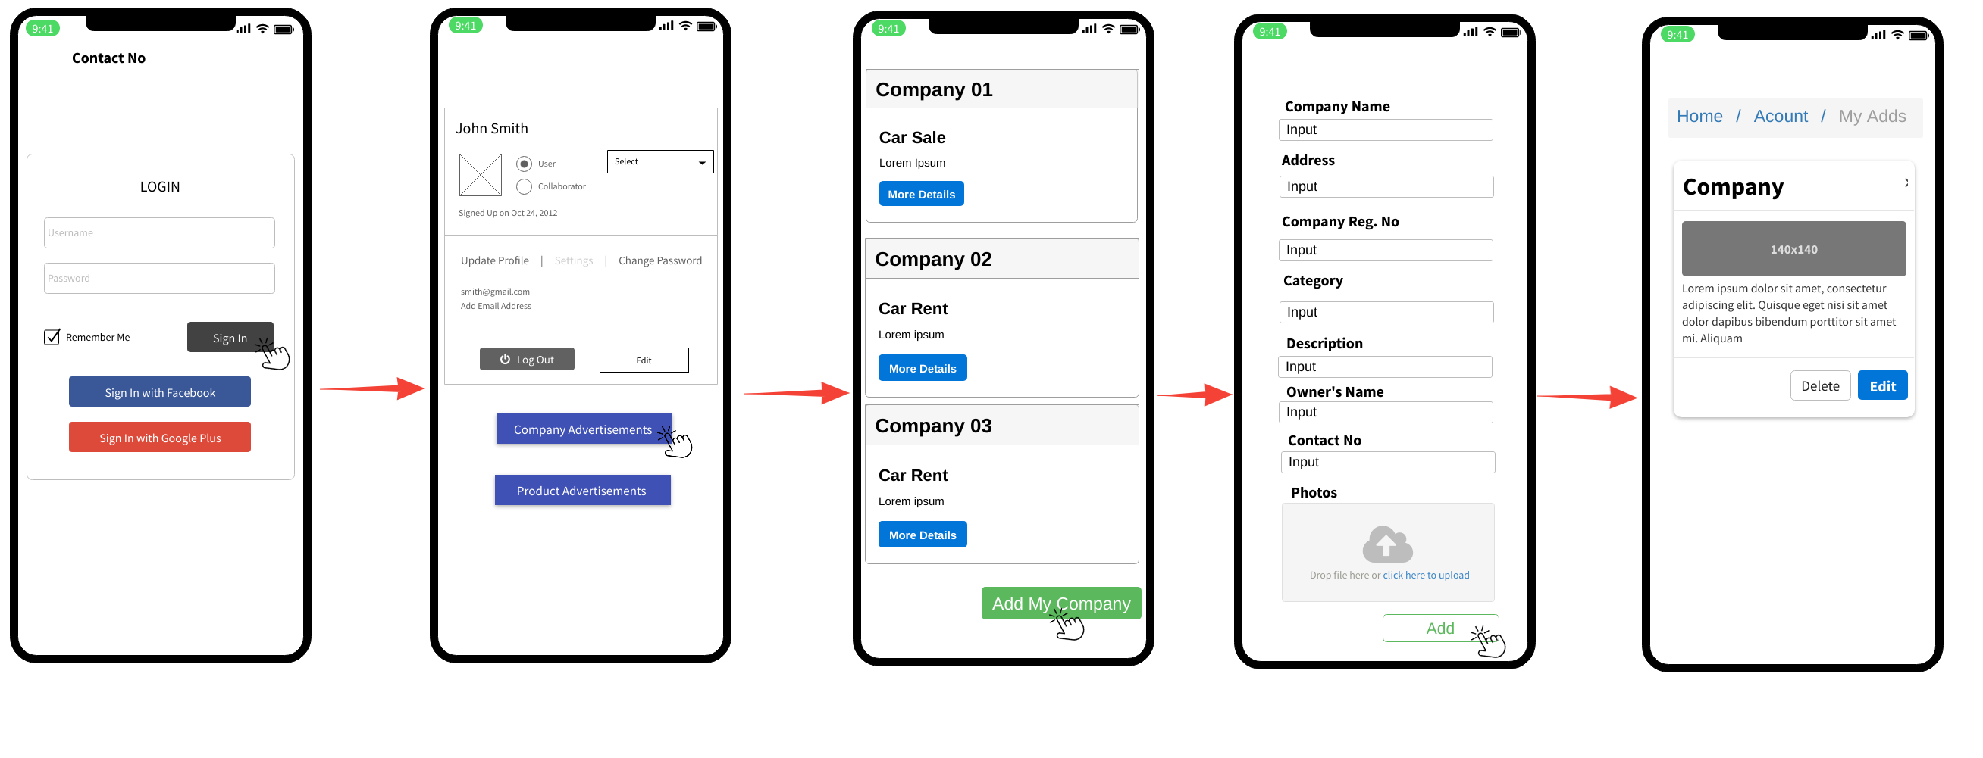

IT19177410 |Madhura Mihiranga H.N.

**Task 01 – persona**

**Hemal Ranasinghe -Actor**

**Background**

* Hemal is trending actor in Sri Lankan cinema. He started his career as a model. He lives in bungalow in Mathale with his parents. apartment with his family. Hemal is a popular person and also he is like to show off his passion with fans.
* He has won the most popular actor awards in 2018. He is a busy person, and he likes to use mobile phone or laptop to do shopping kind of things. Furthermore, Hemal is a classical vehicle lover.

**Demographic**

 Male

Mathale, Sri Lanka

Unmarried

36 Years

Middle Range Income

**Interested Apps:**

* LinkedIn
* Twitter
* Reddit





**Goal**

* Like to be the best actor in Sri Lanka.
* Like to start a vehicle sale.
* Like to create a classical vehicle collection.



**Skills**

* Public Speaking.
* Active Listening.
* Adaptability.
* **Language skills.**

**Task 02 – empathy map**

IT19177410 – Madhura Mihiranga H.N

**Empathy Map** (**Giving feedback after buying product)**

|  |  |
| --- | --- |
| **Male profile outlineSays**  What do I think?  I was expecting something different?  Do I need to review?  Where should I start? | **Thinks**  Did I reach my goal through this?  Do I need to add real information?  What do I post?  What will others think? |
| **Does**  Compare with other products  More research  List pros and cons  Observes in store | **Feels**  Confused  Interest  Bored  Suspicious  **Hemal** |

**Task 03 – user story**

IT19177410 – Madhura Mihiranga H.N

**Title**: **Giving feedback after buying product**

* **As a** customer

**I want to** give a feedback to the seller in this application

**so that** I can aware other users about the product quality.

**Task 04 -User Flow** (**Giving feedback after buying product**)

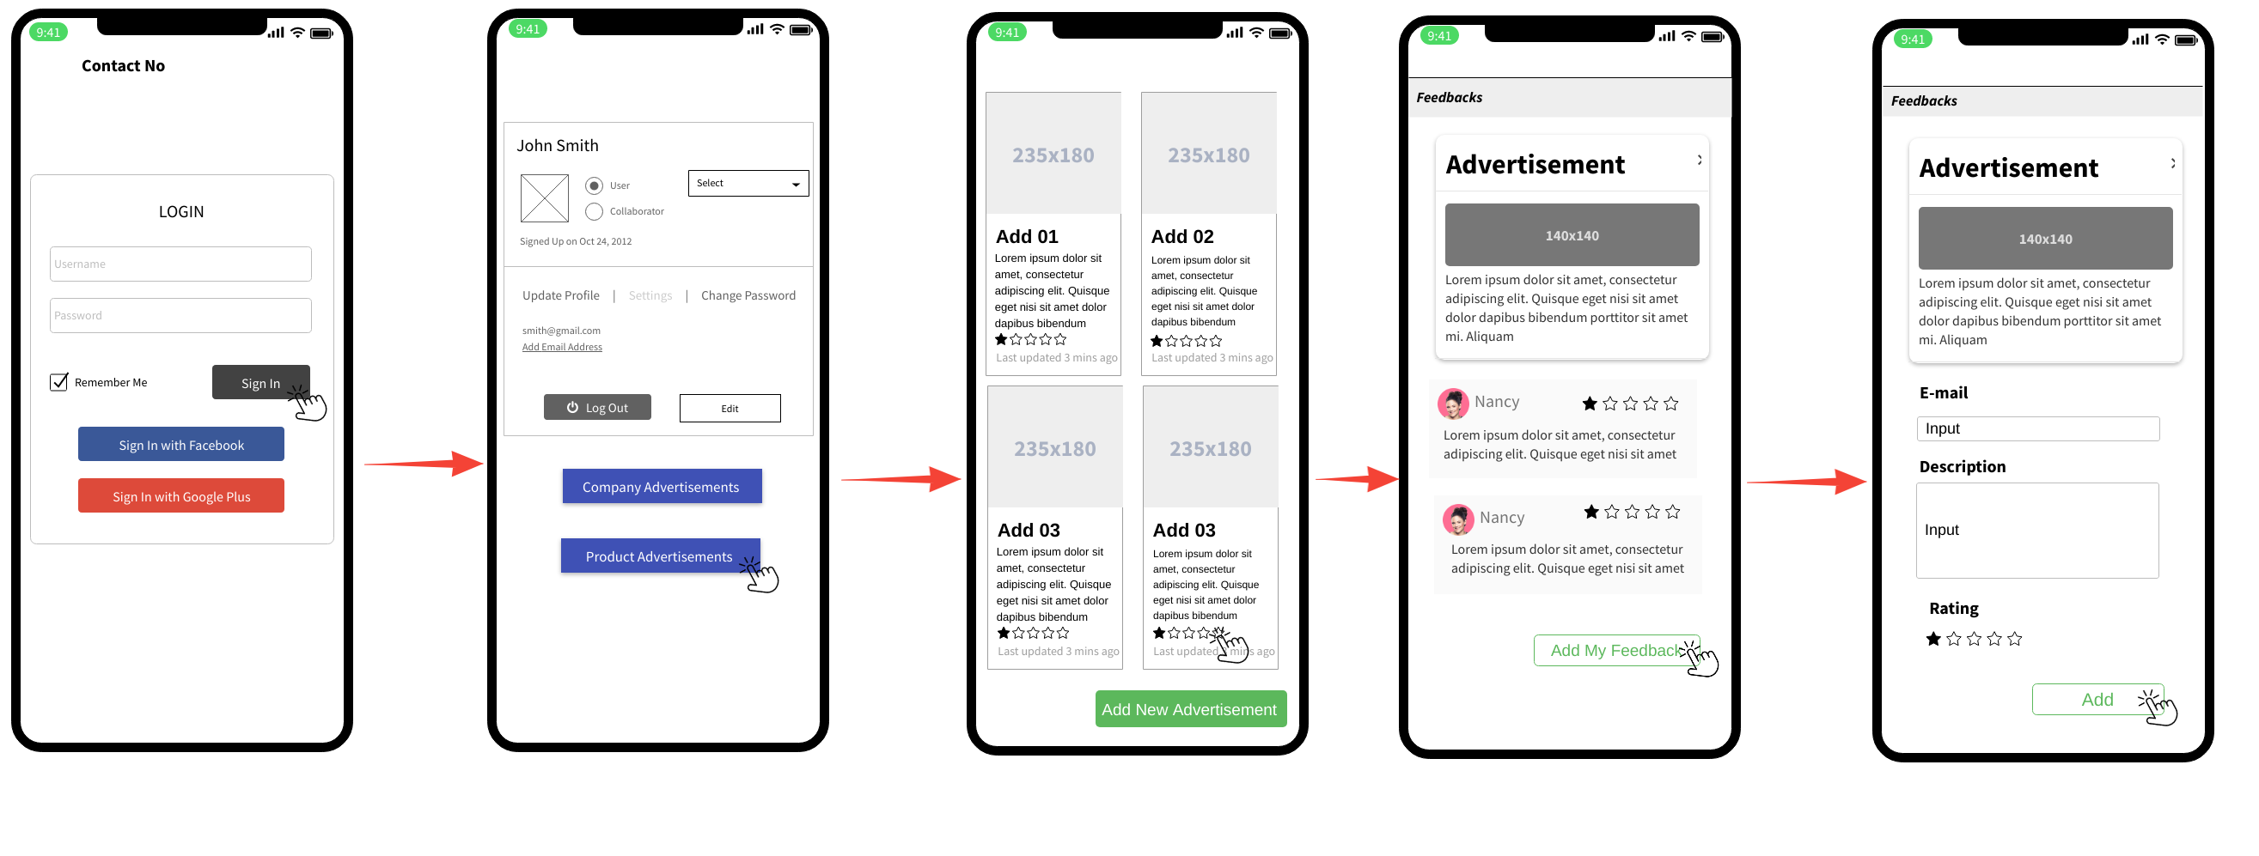

**Task 05 -Service Blueprint**

